**22**

**Electric Fields**

|  |
| --- |
| **CHAPTER OUTLINE** |

22.1 Properties of Electric Charges

22.2 Charging Objects by Induction

22.3 Coulomb’s Law

22.4 Analysis Model: Particle in a Field (Electric)

22.5 Electric Field of a Continuous Charge Distribution

22.6 Electric Field Lines

22.7 Motion of a Charged Particle in a Uniform Electric Field

* An asterisk indicates a question or problem new to this edition.

|  |
| --- |
| **SOLUTIONS TO THINK-PAIR-SHARE AND ACTIVITIES** |

**\*TP22.1 Conceptualize** Imagine the electron in Figure 22.21 is replaced by a nanoparticle. Figure 22.21 demonstrates the curved path followed by the nanoparticle.

**Categorize** Each nanoparticle is modeled as a *particle in an electric field,* a *particle under constant velocity* in the direction parallel to the plates, a *particle under constant acceleration* in the direction perpendicular to the plates, and a *particle under a net force* perpendicular to the plates.

**Analyze** From Equation 22.8, the electric force on a nanoparticle is in the downward direction in Figure 22.21, with magnitude

 (1)

From the particle under a net force model in the vertical direction,

 (2)

From the particle under constant acceleration model, the position of the nanoparticle in the *y* direction at any time is

 (3)

where we have used Equation (2) to substitute for the acceleration. From the particle under constant velocity model, the position of the nanoparticle in the horizontal direction is

 (4)

Suppose we define the initial position of the nanoparticle as just below the left end of the upper plate, so that the nanoparticle enters the field at the highest and leftmost point possible in Figure 22.21. Lets call this point the origin, so Equations (3) and (4) become

 (5)

 (6)

Solve Equation (6) for *t* and substitute into Equation (5):

 (7)

Substitute numerical values to find the vertical position of the nanoparticle as it arrives at position of the end of the plate:



You are embarrassed because no nanoparticles exit your device. The plates are only separated by 8.00 mm, so if the nanoparticles are deflected downward by 8.18 mm from the top edge, they strike the bottom plate before exiting the parallel plates.

**Finalize** Notice in this problem that the acceleration caused by the electric force is comparable in size to that of the gravitational force, so both forces must be included in Equation (2), unlike in Example 22.8. If you left out the gravitational force in your calculation for this problem, your prediction would show that the nanoparticles do indeed leave the plates!

*Answer:* The nanoparticles strike the lower plate and do not exit the device.

**\*TP22.2** *Answers:* (a) + (b) + (c) – (d) – (e) – (f) – (g) – (h) + (i) + (j) – (k) The two materials that are farthest apart on the list are in part (e), silicone and cotton. They are 20 entries apart. However, choice (c), paper and PVC, represents two materials separated by 19 entries. Paper is a little higher into the positive range than is cotton, so it might be a toss-up as to which gives the greater amount of charge transfer.

|  |
| --- |
| **SOLUTIONS TO END-OF-CHAPTER PROBLEMS** |

Section 22.1 Properties of Electric Charges

**P22.1** (a) The charge due to loss of one electron is



The mass of an average neutral hydrogen atom is 1.007 9 u. Losing one electron reduces its mass by a negligible amount, to



(b) By similar logic, charge 



(c) Gain of one electron: charge of 



(d) Loss of two electrons: charge of  



(e) Gain of three electrons: charge of  



(f) Loss of four electrons: charge of  



(g) We think of a nitrogen nucleus as a seven-times ionized nitrogen atom. 



(h) Gain of one electron: charge 



Section 22.3 Coulomb’s Law

**P22.2** (a) The two ions are both singly charged, , one positive and one negative. Thus,



(b) No. The electric force depends only on the magnitudes of the two charges and the distance between them.

**P22.3** The electric force is given by



**P22.4** Suppose each person has mass 70 kg. In terms of elementary charges, each person consists of precisely equal numbers of protons and electrons and a nearly equal number of neutrons. The electrons comprise very little of the mass, so for each person we find the total number of protons and neutrons, taken together:



Of these, nearly one half, 2  1028, are protons, and 1% of this is   
2   1026, constituting a charge of (2  1026)(1.60  10–19 C) = 3  107 C.

Thus, Feynman’s force has magnitude



where we have used a half-meter arm’s length. According to the particle in a gravitational field model, if the Earth were in an externally-produced uniform gravitational field of magnitude   
9.80  m/s2, it would weigh *Fg* = *mg* = (6  1024 kg)(10 m/s2) ~1026 N.

Thus, the forces are of the same order of magnitude.

**P22.5** (a) 



(b) The charges are like charges. 

**\*P22.6 Conceptualize** The Earth and the Moon are far apart compared to their radii, so they can be modeled as point charges.

**Categorize** With the modeling proposed in the Conceptualize step, this problem becomes a simple calculation of an electric force between two charged particles.

**Analyze** Using Equation 22.1, the magnitude of the electric force between the Earth and the Moon is



This is a very small force on a planetary scale. In comparison, the gravitational force between the Earth and the Moon is



This force is 18 orders of magnitude larger than the electric force we calculated.

**Finalize** Because of its small magnitude, the electric force cannot have any influence on the Moon when compared to gravitational forces. That is likely what the professor had raised his hand about. Check your calculations before giving a presentation!

*Answer:* The electric force is 18 orders of magnitude smaller than the gravitational force.

**P22.7** (a) Let the third bead have charge *Q* and be located distance *x* from the left end of the rod. This bead will experience a net force given by

, where *d* = 1.50 m

The net force will be zero if , or .

This gives an equilibrium position of the third bead of

*x* = 0.634*d* = 0.634(1.50 m) = 

(b)  The equilibrium would be stable because if charge *Q* were displaced either to the left or right on the rod, the new net force would be opposite to the direction *Q* has been displaced, causing it to be pushed back to its equilibrium position.

**P22.8** (a) Let the third bead have charge *Q* and be located distance *x* from the left end of the rod. This bead will experience a net force given by



The net force will be zero if 

 because *d* > *x.* Thus,



(b)  The equilibrium would be stable because if charge *Q* were displaced either to the left or right on the rod, the new net force would be opposite to the direction *Q* has been displaced, causing it to be pushed back to its equilibrium position.

**P22.9** (a)  toward the other particle.

(b) We have  from which



**P22.10** The forces are as shown in ANS. FIG. P22.10.

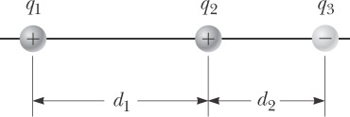

**ANS. FIG. P22.10**







(a) The net force on the 6 *µ*C charge is



(b) The net force on the 1.5 *µ*C charge is



(c) The net force on the –2 *µ*C charge is



**P22.11** The force due to the first charge is given by

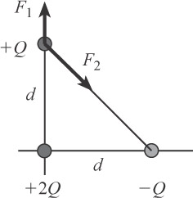

**ANS. FIG. P22.11**



and the force due to the second charge is given by



thus the total force on the point charge +Q located at *x* = 0

and *y* = *d* is



**P22.12** Charge C is attracted to charge B and repelled by charge A, as shown in

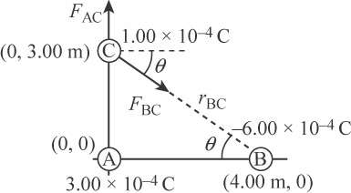

**ANS. FIG. P22.12**

ANS. FIG. P22.12. In the sketch,



and



(a) 

(b) 



(c) 

(d) 

(e) 

(f) 

(g) 

(h) 

Both components are positive, placing the force in the first quadrant:



Therefore, 

**P22.13** Each charge exerts a force of magnitude  on the negative charge *–Q*: the top charge exerts its force directed upward and to the left, and bottom charge exerts its force directed downward and to the left, each at angle , respectively, above and below the *x* axis. The two positive charges together exert a net force:



or for , 

(a) 

(b) , where *m* is the mass of the object with charge –*Q*.

(c) 

**P22.14** Each of the dust particles is a particle in equilibrium. Express this mathematically for one of the particles:



where we have recognized that the gravitational force is attractive and the electric force is repulsive, so the forces on one particle are in opposite directions. Substitute for the forces from Coulomb’s law and Newton’s law of universal gravitation, and solve for *q*, the unknown charge on each dust particle:



Substitute numerical values:



This is about half of the smallest possible free charge, the charge of the electron. No such free charge exists. Therefore, the forces cannot balance. Even if the charge on each dust particle is due to one electron, the net force will be repulsive and the particles will move apart.

Section 22.4 Analysis Model: Particle in a Field (Electric)

**P22.15** For equilibrium,  or  Thus,



(a) For an electron,



(b) For a proton, which is 1 836 times more massive than an electron,



**P22.16** (a) One of the charges creates at *P* a field

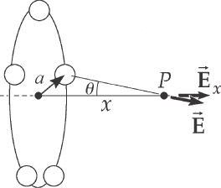

**ANS. FIG. P22.16**



at an angle *θ* to the *x* axis as shown in ANS. FIG. P22.16. When all the charges produce the field, for *n* > 1, by symmetry the components perpendicular to the *x* axis add to zero.

The total field is then



(b) 

**P22.17** (a) See ANS. FIG. P22.17(a). The distance from the +*Q* charge on the upper left is *d*, and the distance from the +*Q* charge on the lower right to point *P* is

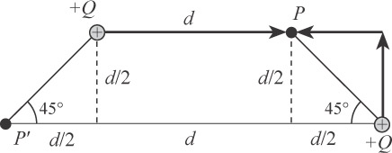

**ANS. FIG. P22.17(a)**



The total electric field at point *P* is then



(b) See ANS. FIG. P22.17(b). The distance from the +Q charge on the lower right to point P’ is 2*d*, and the distance from the +*Q* charge on the upper right to point *P*′is

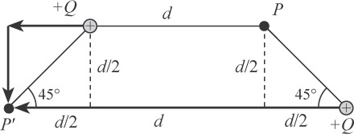

**ANS. FIG. P22.17(b)**



The total electric field at point *P’* is then



**P22.18** The first charge creates at the origin a field  to the right. Both charges are on the *x* axis, so the total field cannot have a vertical component, but it can be either to the right or to the left. If the total field at the origin is to the right, then *q* must be negative:

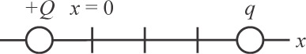

**ANS. FIG. P22.18**



In the alternative, if the total field at the origin is to the left,





**P22.19** Call *Q* = 3.00 nC and *q* = |–2.00 nC|= 2.00 nC,   
and *r* = 4.00 cm = 0.040 0 m. Then,

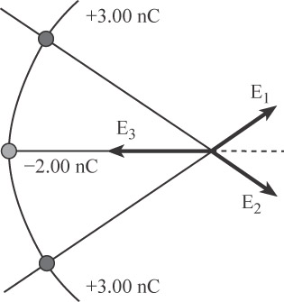

**ANS. FIG. P22.19**

 and 

Then,



(a) 

(b) The electric force on a point charge placed at point *P* is



**P22.20** (a) The distance from each charge to the point at *y* = 0.500 m is



**ANS. FIG. P22.20**



the magnitude of the electric field from   
each charge at that point is then given by



The *x* components of the two fields cancel and the *y* components add, giving

 and 

so 

(b) The electric force at this point is given by



**P22.21** (a) The electric field at the origin due to each of the charges is given by





and their sum is





**ANS. FIG. P22.21**

(b) The vector electric force is





**P22.22** The electric field at any point *x* is



When *x* is much, much greater than *a*, we find 

Section 22.5 Electric Field Lines

**P22.23** (a) The electric field has the general appearance shown in ANS. FIG. P22.23 below.

(b) It is zero , where (by symmetry) one can see that the three charges individually produce fields that cancel out.

In addition to the center of the triangle, the electric field lines in the second panel of ANS. FIG. P22.23 indicate three other points near the middle of each leg of the triangle where *E* = 0, but they are more difficult to find mathematically.

(c) You may need to review vector addition in Chapter 1. The electric field at point *P* can be found by adding the electric field vectors due to each of the two lower point   
charges: 

The electric field from a point charge is   


As shown in the bottom panel of

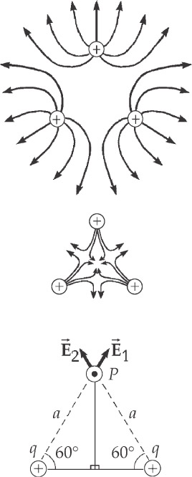

**ANS. FIG. P22.23**

ANS. FIG. P22.23,



to the right and upward at 60°, and



to the left and upward at 60°. So,



Section 22.6 Motion of a Charged Particle in a Uniform   
Electric Field

**P22.24** (a) We obtain the acceleration of the proton from the particle under a net force model, with *F* = *qE* representing the electric force:



(b) The particle under constant acceleration model gives us  from which we obtain



(c) Again, from the particle under constant acceleration model,



(d) The final kinetic energy of the proton is



**P22.25**  is directed along the *y* direction; therefore, *ax* = 0 and *x* = *vxit*.

(a) 

(b) 





(c) 





**P22.26** (a) 



**ANS. FIG. P22.26**

(b) 

(c) The vertical acceleration caused by the   
electric force is constant and downward;

therefore, the proton moves in a parabolic path just like a projectile in a gravitational field.

(d) We may neglect the effect of the acceleration of gravity on the proton because the magnitude of the vertical acceleration caused by the electric force is



which is much greater than that of gravity.

Replacing acceleration *g* in Equation 4.20 with *eE*/*m*P, we have



(e) 

which gives  or

 or 

(f) 

If  . If , 

**\*P22.27 Conceptualize** Imagine the electron in Figure 22.21 is replaced by an ink drop. Figure 22.21 demonstrates the curved path followed by the ink drop. Now rotate the entire figure clockwise by 90° to represent the fact that the ink drops are fired downward into the region between the plates.

**Categorize** Each ink drop is modeled as a *particle in field (electric),* a *particle under constant velocity* in the direction parallel to the plates, a *particle under constant acceleration* perpendicular to the plates, and a *particle under a net force* perpendicular to the plates.

**Analyze** From Equation 22.8, the electric force on an ink drop is in the horizontal direction in the rotated version of Figure 22.21, with magnitude

 (1)

From the particle under a net force model in the horizontal direction,

 (2)

From the particle under constant acceleration model, the position of the ink drop in the *x* direction at any time is

 (3)

where we have used Equation (2) to substitute for the acceleration. From the particle under constant velocity model, the position of the ink drop in the vertical direction is

 (4)

Define *yi* = 0 as the point at which the ink drop enters the top of the parallel plates. Incorporate this idea into Equation (4) and solve for *t*:

 (5)

Solve Equation (3) for the horizontal deflection of an ink drop and substitute for the time from Equation (5):

 (6)

We want a particular deflection ∆*x* at the instant when the ink drop arrives at the lower end of the plates, so that *yf* = 

 (7)

Solve Equation (7) for the required charge:



Substitute numerical values:



**Finalize** The sign of the charge is not important, since we were only provided with a magnitude of the deflection, with no direction indicated.

*Answer:* 4.52 × 10–14 C

**\*P22.28 Conceptualize** The electric field between the plates will cause the path of the electrons to curve downward after being projected in the direction shown in Figure P22.28. In a very strong electric field, the downward force on the electrons will cause them to strike the lower plate. For a certain value of the electric field, the electrons will follow a trajectory and exit the apparatus by just missing the right edge of the lower plate.

**Categorize** The electrons will be modeled as *particles in a field (electric),* *particles under constant acceleration* in the vertical direction, and *particles under constant velocity* in the horizontal direction.

**Analyze** (a) The largest *positive* angle relative to the *x* axis at which the electrons leave the apparatus, in the absence of an electric field, is the same as the initial angle of projection of the electrons into the apparatus, and can be determined from Figure P22.28:

 (1)

where the subscript *i* indicates the *initial* angle at which the electrons enter the apparatus. The largest *negative* angle relative to the *x* axis at which the electrons leave the apparatus is determined by the curve that the electrons follow when there is an electric field between the plates.

Because the magnitude of the electric force on the electron is given by Equation 22.8, *Fe* = *qE*, which is constant like the gravitational force on a particle, given by Equation 5.5, *Fg* = *mg*, we expect the path of the electron between the plates to be parabolic, as discussed for a projectile in a gravitational field in Chapter 4. For the critical situation in which the electron just misses the right edge of the lower plate, the trajectory is similar to that of the projectile in Figure 4.8. Based on that figure, because the electron returns to the same vertical position from which it began, its angle as it arrives at that position is the same as the initial angle, but with a negative value. Therefore, the range of values of the angles of the electrons leaving the apparatus is

 (1)

Substitute numerical values:



(b) Now, let’s find the electric field that will cause just the right trajectory to give us the maximum possible deviation angle for the electron. Combine the particle in a field model, Equation 22.8, and the particle under a net force model to determine the vertical acceleration of the electron:

 (2)

Because everything on the right side of Equation (2) is constant, we can model the electron as a particle under constant acceleration in the vertical direction. Therefore, the vertical position of the electron at any time is given by the vertical component of Equation 4.9:

 (3)

Define the left edge of the lower plate as the origin, and substitute for the acceleration from Equation (2):

 (4)

Because there is no force on the electron in the horizontal direction, we can model the electron as a particle under constant velocity in that direction. Therefore, the horizontal position of the electron at any time is given by the horizontal component of Equation 4.9:

 (5)

Let us imagine the electron follows a parabolic trajectory and exits the apparatus at the right edge of the lower plate, which is defined as  and *yf* = 0. Then Equations (4) and (5) become

 (6)

 (7)

Solve Equation (7) for *t*, substitute the result into Equation (6), and then solve the resulting equation for the electric field *E*:

 (8)

Substitute for the sine and cosine from Figure P22.28:



Substitute numerical values:



**Finalize** Solve Equation (8) for the plate length 



Recognize the combination 2sin*i* cos*i* = sin2*i*, and substitute for the denominator from Equation (2):



Compare this equation to the range equation, Equation 4.20. The equations are the same, recognizing that *ay* = –*g* for the gravitational situation described by Equation 4.20! The path of the electron is a parabolic projectile, just like a thrown projectile in a gravitational field. Because the electrons arrive at the bottom plate just at its right edge, the length  of the plate is the same as the range *R* of the gravitational projectile.

*Answers:* (a)  (b) 34.0 N/C

**Additional Problems**

**P22.29** The electric field is given by the sum of the fields due to each of the *n* particles:



**P22.30** The positive charge, call it *q*, is 50.0 cm – 20.9 cm = 29.1 cm from charge *Q*. The force on *q* from the –3.00 nC charge balances the force on *q* from the *–Q* charge:



which then gives



**P22.31** (a) Take up the incline as the positive x direction. Newton’s second law along the incline gives



solving for the electric field gives



(b) The electric force must be up the incline, so the electric field must point down the incline because the charge is negative.



**P22.32** The downward electric force on the 0.800 *µ*C charge is balanced by the upward spring force:



solving for the spring constant gives



**P22.33** ANS. FIG. P22.33 shows the free-body diagram for Newton’s second law gives

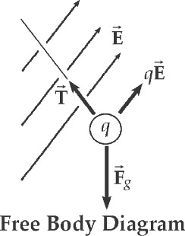

**ANS. FIG. P22.33**



We are given

*Ex* = 3.00  105 N/C

and *Ey* = 5.00  105 N/C

Applying Newton’s second law or the first condition for equilibrium in the *x* and *y* directions,

 **[1]**

 **[2]**

(a) We solve for *T* from equation [1]:



and substitute into equation [2] to obtain





(b) Using the above result for *q* in equation [1], we find that the tension is



**P22.34** This is the general version of the preceding problem . The known quantities are *A*, *B*, *m*, *g*, and *θ*. The unknowns are *q* and *T*.

Refer to ANS. FIG. P22.33 above. The approach to this problem should be the same as for the last problem, but without numbers to substitute for the variables. Likewise, we can use the free body diagram given in the solution to problem 51.

Again, from Newton’s second law,

 **[1]**

and  **[2]**

(a) Substituting  into equation [2], we obtain



Isolating *q* on the left,



(b) Substituting this value into equation [1], we obtain



If we had solved this general problem first, we would only need to substitute the appropriate values in the equations for *q* and *T* to find the numerical results needed for problem 24. If you find this problem more difficult than problem 24, the little list at the first step is useful. It shows what symbols to think of as known data, and what to consider unknown. The list is a guide for deciding what to solve for in the analysis step, and for recognizing when we have an answer.

**P22.35** (a) Refer to ANS. FIG. P22.35(a). The field, *E*1, due to the 4.00 × 10–9 C charge is in the –*x* direction.



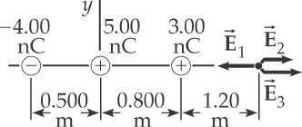

**ANS. FIG. P22.35(a)**

Likewise, *E*2 and *E*3, due to the 5.00 × 10–9 C charge and the   
3.00 × 10–9 C charge, are







(b) In this case, referring to ANS. FIG. P22.35 (b),





The components of the resultant electric field are



then, the magnitude of the resultant electric field is



and is directed at



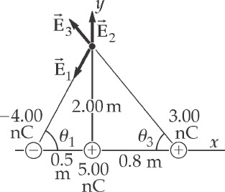

**ANS. FIG. P22.35(b)**

**P22.36** (a) The two given charges exert equal size forces of attraction on each other. If a third charge, positive or negative, were placed between them they could not be in equilibrium. If the third charge were at a point   
*x* > 15.0 cm, it would exert a stronger force on the 45.0-*µ*C charge than on the –12.0-*µ*C charge, and could not produce equilibrium for both. Thus the third charge must be at *x* = –*d* < 0. 

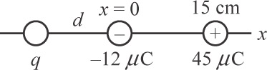

**ANS. FIG. P22.36**

(b) The equilibrium of the third charge requires



Solving,



The third charge is at .

(c) The equilibrium of the –12.0-*µ*C charge requires



solving,



All six individual forces are now equal in magnitude, so we have equilibrium as required, and this is the only solution.

**P22.37** We model the spheres as particles. They have different charges. They exert on each other forces of equal magnitude. They have equal masses, so their strings make equal angles *θ* with the vertical. We define *r* as the distance between the centers of the two spheres. We find *r* from



from which we obtain



Now let *T* represent the string tension. We have, from the particle under a net force model,

 **[1]**

 **[2]**

Dividing equation [1] by [2] to eliminate *T* gives



Clearing the fractions,



Substituting numerical values gives



Suppressing units,

(0.800)2 – *r*2 = 1 901 *r*6

Instead of attempting to solve this equation, we instead home in on a solution by trying values, tabulated below:

|  |  |
| --- | --- |
| *r* | 0.640 – *r*2 – 1901 *r*6 |
| 0 | +0.64 |
| 0.5 | –29.3 |
| 0.2 | +0.48 |
| 0.3 | –0.84 |
| 0.24 | +0.22 |
| 0.27 | –0.17 |
| 0.258 | +0.013 |
| 0.259 | –0.001 |

Thus the distance to three digits is 0.259 m = 

**P22.38** The magnitude of the electric force is given by . The angle  in   
ANS. FIG. P22.38 is found from

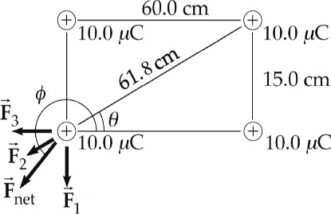

**ANS. FIG. P22.38**







(a) 

(b) 

**P22.39** Charge *Q* resides on each of the blocks, which repel as point charges:



Solving for *Q*, we find



**P22.40** Charge *Q* resides on each of the blocks, which repel as point charges:



Solving for *Q*, we find



**P22.41** Consider the free-body diagram of the rightmost charge given in ANS. FIG. P22.41. Newton’s second law then gives



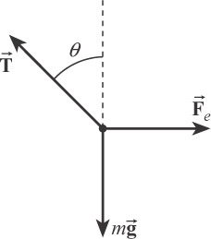

**ANS. FIG. P22.41**

and



But,



Thus,

 or 

If  then



or 

**P22.42** Use Figure 22.21 for guidance on the physical setup of this problem. Let the electron enter at the origin of coordinates at the left end and just under the upper plate, which we choose to be negative so that the electron accelerates downward. The electron is a particle under constant velocity in the horizontal direction:



The electron is a particle under constant acceleration in the vertical direction:



Eliminate *t* between the equations:



Substitute for the acceleration of the particle in terms of the electric force:



Substitute numerical values, letting the final horizontal position be at the right end of the plates:



Therefore, when the electron leaves the plates, its final position is well below that of the lower plate, which is at position *y* = –1.50 cm =  
 –0.015 m. Consequently, because we have let the electron enter the field at as high a position as possible, the electron will strike the lower plate long before it reaches the end, regardless of where it enters the field.

**P22.43** The charges are *q* and *2q*. The magnitude of the   
repulsive force that one charge exerts on the other is

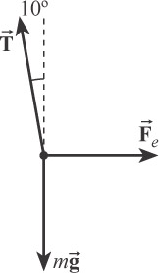

**ANS. FIG. P22.43**



From Figure P22.43 in the textbook, observe that   
the distance separating the two spheres is



From the free-body diagram of one sphere given   
in ANS. FIG. P22.43, observe that



and



Thus,



or



giving 

**P22.44** (a) The bowl exerts a normal force on each bead, directed along the radius line at angle *θ* above the horizontal. Consider the free-body diagram shown in ANS. FIG. P22.44 for the bead on the left side of the bowl:



Also,



which gives

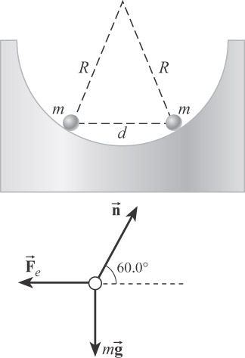

**ANS. FIG. P22.44**



The electric force is



And from ANS. FIG. P22.44,



Therefore,



(b) As *d* → 2*R*, ; therefore, .

**P22.45** (a) From the 2*Q* charge we have

 and 

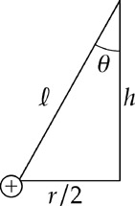

**ANS. FIG. P22.45**

Combining these we find



From the *Q* charge we have

 and 

Combining these we find

 or 

(b) . If we assume *θ* is small then 

Substitute expressions for *Fe* and tan*θ* into either equation found in part (a) and solve for *r.*  then  and solving for *r* we find 

**\*P22.46 Conceptualize** The amount of charge necessary to counteract the gravitational force on a human is very large. When two such charged humans are close together, there is a large repulsive force between them, which will cause them to accelerate away from each other.

**Categorize** A single human is modeled as a *particle in a field (electric)* for the hovering experiment, as well as a *particle in equilibrium* between the electric and gravitational forces. When two humans are hovering, each is a particle in the electric field of the other, and the repulsive force between them is represented by Coulomb’s law. Then they can each also be modeled as a *particle under a net force.*

**Analyze** Let’s first look at the hovering of a single experimental subject. Model the subject as a particle in equilibrium, with the gravitational force downward and the electric force, given by Equation 22.8, upward:

 (1)

which is the charge necessary to be applied to the body to make the experimental subject hover. Now imagine that there are two hovering subjects with the same mass and charge. Modeling them as particles, they will feel a repulsive force according to Coulomb’s law in Equation 22.1:

 (2)

Now model one of the experimental subjects as a particle under a net force in the horizontal direction. The only force in this direction is the electrical repulsion from the other subject, so we can find the horizontal acceleration of this experimental subject:

 (3)

Substitute numerical values given in the problem, using the fact that the experimental subjects are working 1.00 m apart:



**Finalize** This is a *tremendous* acceleration, millions of times larger than that for gravity. The experimental subjects would be lucky to survive this experiment. You should advise the inventor that he should have warned the experimental subjects about this possibility, and the most likely outcome of a trial would be that he will be ruled responsible for the injuries to his experimental subjects.

*Answer:* 4.34 × 109 m/s2

**P22.47** (a) The total non-contact force on the cork ball is:



which is constant and directed downward. Therefore, it behaves like a simple pendulum in the presence of a modified uniform gravitational field with a period given by:



(b) . Without gravity in part (a), we get



  
(a 2.28% difference).

**Challenge Problems**

**P22.48** First, we use unit vectors to find the total electric field at point *A* produced by the 7 other charges.

|  |  |  |
| --- | --- | --- |
| source charge | vector field components | equivalent field |
| (1) lower left,  front: |  |  |
| (2) lower right,  front: |  |  |
| (3) lower right,  back: |  |  |
| (4) lower left,  back: |  |  |
| (5) upper right,  back |  |  |
| (6) upper left,  back |  |  |
| (7) upper right,  front |  |  |
| total field | | |

Notice that because of symmetry, the components of the field have the same magnitude.

(a) At point *A*,





(b) 

(c) 

**P22.49** (a) The two charges create fields of equal magnitude, both with outward components along the *x* axis and with upward and downward *y* components that add to zero. The net field is then





(b) At *x* = 0.36 m,



(c) We solve 1 000 = (935 *x*)(0.0625 + *x*2)–3/2 by tabulating values for the field function:

|  |  |
| --- | --- |
| *x* | (935 *x*)(0.0625 + *x*2)–3/2 |
| 0 | 0 |
| 0.01 | 597 |
| 0.02 | 1 185 |
| 0.1 | 4 789 |
| 0.2 | 5 698 |
| 0.36 | 4 000 |
| 0.9 | 1 032 |
| 1 | 854 |
| ∞ | 0 |

We see that there are two points where *E* = 1 000 N/C. We home in on them to determine their coordinates as (to three digits)   


(d) The table in part (c) shows that 

**P22.50** (a) The electrostatic forces exerted on the two charges result in a net torque

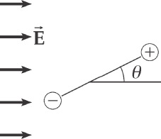

**ANS. FIG. P22.50**



For small *θ*, and using *p* = 2*qa*, we have



The torque produces an angular acceleration given by



where the moment of inertia of the dipole is *I* = 2*ma*2

Combining the two expressions for torque, we have



This equation can be written in the form  which is the standard equation characterizing simple harmonic motion, with



The frequency of oscillation is  so



(b) If the masses are unequal, the dipole will oscillate about its center of mass (CM). Assume mass *m*2 is greater than mass *m*1, and treat the *center* of the dipole as being at the origin of an *x* axis, so that mass *m*1 is at *x = –a* and mass *m*2 is at *x = +a*. The coordinate of the CM of the dipole is then



relative to the center of the dipole. Notice that the moment of inertia of the dipole about its *center* is



but its center is a distance *x*cm from its CM. By the parallel-axis theorem, the moment of inertia of the dipole about its *center* is related to its moment about its CM thus:



therefore,



The moment of inertia of the dipole about its CM is then







Therefore, from part (a),



and



|  |
| --- |
| **ANSWERS TO QUICK-QUIZZES** |

**1.** (a), (c), (e)

**2.** (e)

**3.** (b)

**4.** (a)

**5.** *A*, *B*, *C*

|  |
| --- |
| **ANSWERS TO EVEN-NUMBERED PROBLEMS** |

**P22.2** (a) 9.21 × 10–10 N; (b) No. The electric force depends only on the magnitudes of the two charges and the distance between them.

**P22. 4** ~1026 N

**P22. 6** The electric force is 18 orders of magnitude smaller than the gravitational force.

**P22. 8** (a) ; (b) Yes, if the third bead has a positive charge.

**P22.10** (a) 46.7 N to the left; (b) 157 N to the right; (c) 111 N to the left

**P22.12** (a) 0; (b) 30.0 N; (c) 21.6 N; (d) 17.3 N; (e) –13.0 N; (f) 17.3 N; (g) 17.0 N;  
(h) 24.3 N at 44.5° above the +*x* direction

**P22. 14** The unknown charge on each dust particle is about half of the smallest possible free charge, the charge of the electron. No such free charge exists. Therefore, the forces cannot balance.

**P22. 16** (a) ; (b) A circle of charge corresponds to letting *n* grow beyond all bounds, but the result does not depend on *n*. Because of the symmetrical arrangement of the charges, smearing the charge around the circle does not change its amount or its distance from the field point, so it does not change the field.

**P22. 18** The field at the origin can be to the right, if the unknown charge is   
–9*Q*, or the field can be to the left, if and only if the unknown charge is +27*Q*.

**P22. 20** (a) ; (b) 

**P22. 22** 

**P22. 24** (a) 6.13 × 1010 m/s2 (b) 1.96 × 1025 s (c) 11.7 m (d) 1.20 × 10-15 J

**P22. 26** (a) Particle under constant velocity; (b) Particle under constant acceleration; (c) the proton moves in a parabolic path just like a projectile in a gravitational field; (d) ; (e) 36.9° or 53.1°; (f) 166 ns or 221 ns

**P22. 28** (a)  (b) 34.0 N/C

**P22. 30** 5.81 nC

**P22. 32** 49.3 N/m

**P22. 34** (a) ; (b) 

**P22. 36** (a) It is possible in just one way; (b) *x* = –16.0 cm; (c) 

**P22. 38** (a) 40.9 N; (b) 263°

**P22. 40 **

**P22. 42** See P22.42 for complete solution

**P22. 44** (a) ****;(b) 

**P22. 46** 4.34 × 109 m/s2

**P22. 48** (a) (b) 

(c) 

**P22. 50** (a)  (b) 